The following document provides a template for all members of staff in Faculties and Professional Service Departments, currently working from home during the COVID-19 Pandemic, to complete a COVID-19 Workstation Self-Assessment. This document should be read in conjunction with the University’s Display Screen Equipment Policy (P012) document: https://www.aber.ac.uk/en/media/departmental/healthsafetyenvironment/documentmanagementsystem/policiesandprocedures/P012-Display-Screen-Equipment-Policy.pdf
The requirement to complete this form applies to all University members of staff who are working from home as a result of the ongoing COVID-19 Pandemic. The DSE Workstation Self-Assessment Form (Step 2) can be completed using this document, or online at: https://myadmin.aber.ac.uk/
Name: Department:
Username: Line Manager:
Date:
Step 1 – E-Learning Training
All staff continuing to work from home for a prolonged period are asked to complete the ‘Working Safely with Computers’ Health and Safety Essentials E-Learning Training Module. In instances where individuals may have previously completed the module, but not within the past 12 months, members of staff should endeavour to complete the module again, as refresher training. The module will take around 20 minutes to complete.
The Health and Safety Essentials E-Learning Training package, which includes the ‘Working Safely with Computers’ module, is available to all members of staff via Blackboard. The module can be accessed by:
- Logging into Blackboard: https://blackboard.aber.ac.uk
- Clicking on the ‘My Modules’ tab on the top right hand side of the page.
- Selecting ‘BBHS001: Health, Safety & Environmental Training’ under ‘My Modules 2019-20’.
- Clicking on ‘Course Documents’, which will show the available modules.
- Selecting ‘Working Safely with Computers’ from the available modules.
Further information relating to the Health and Safety Essentials E-Learning Modules is available at: https://www.aber.ac.uk/en/hse/training/hseessentials/
Please ensure that a copy of the certificate of completion is taken, to be submitted alongside this form, as evidence of completion.

Step 2 – Display Screen Equipment (DSE) Assessment
The following checklist provides a framework whereby users of display screen equipment (DSE) through their homeworking can review the suitability of their workstation areas, and identify any areas which may require addressing.
- Display Screens
Considerations | Ways of reducing the risk | Yes | No | Action(s) to take
Are the characters clear and readable?  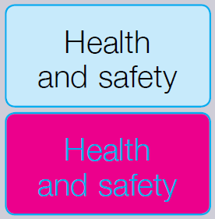 | Make sure the screen is clean and cleaning materials are available.  Check that the text and background colours work well together. | ☐ | ☐
Is the text size comfortable to read? | Software settings may need adjusting to change text size. | ☐ | ☐
Is the image stable, i.e. free of flicker and jitter? | Try using different screen colours to reduce flicker, e.g. darker background and lighter text.  If there are still problems, get the set-up checked, e.g. by the equipment supplier. | ☐ | ☐
Is the screen’s specification suitable for its intended use? | For example, intensive graphic work or work requiring fine attention to small details may require large display screens. | ☐ | ☐
Are the brightness and/or contrast adjustable? | Separate adjustment controls are not essential, provided the user can read the screen easily at all times. | ☐ | ☐
Does the screen swivel and tilt?  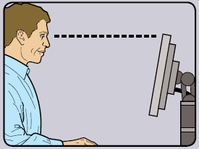 | Swivel and tilt need not be built in; you can add a swivel and tilt mechanism.  However, you may need to replace the screen if:  - swivel/tilt is absent or unsatisfactory;  - work is intensive; and/or  - the user has problems getting the screen to a comfortable position. | ☐ | ☐
Is the screen free from glare and reflections?  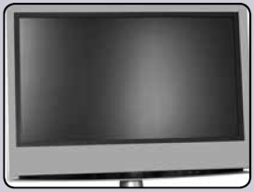 | Use a mirror placed in front of the screen to check where reflections are coming from.  You might need to move the screen or even the desk and/or shield the screen from the source of the reflections.  Screens that use dark characters on a light background are less prone to glare and reflections. | ☐ | ☐
Are adjustable window coverings provided and in adequate condition? | Check that blinds work. Blinds with vertical slats can be more suitable than horizontal ones.  If these measures do not work, consider anti-glare screen filters as a last resort and seek specialist help. | ☐ | ☐
- Keyboards
Considerations | Ways of reducing the risk | Yes | No | Action(s) to take
Is the keyboard separate from the screen (if using a PC)? | This is a requirement, unless the task makes it impracticable or where a portable device is used e.g. laptop. | ☐ | ☐
Does the keyboard tilt? | Tilt need not be built in. | ☐ | ☐
Is it possible to find a comfortable keying position?  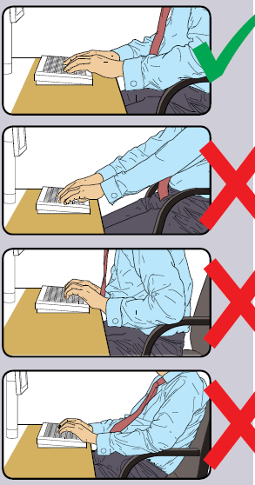 | Try pushing the display screen further back to create more room for the keyboard, hands and wrists.  Users of thick, raised keyboards may need a wrist rest. | ☐ | ☐
Does the user have good keyboard technique? | Training can be used to prevent:  - hands bent up at the wrist;  - hitting the keys too hard;  - overstretching the fingers. | ☐ | ☐
Are the characters clear and readable? | Keyboards should be kept clean. If characters still can’t be read, the keyboard may need modifying or replacing.  Use a keyboard with a matt finish to reduce glare and/or reflection. | ☐ | ☐
- Mouse, trackball, etc.
Considerations | Ways of reducing the risk | Yes | No | Action(s) to take
Is the device suitable for the tasks it is used for? | If the user is having problems, try a different device. The mouse and trackball are general-purpose devices suitable for many tasks, and available in a variety of shapes and sizes. Alternative devices such as touch screens may be better for some tasks (but can be worse for others). | ☐ | ☐
Is the device positioned close to the user?  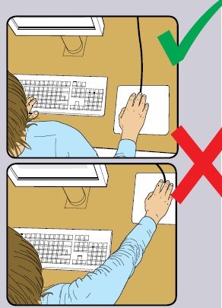 | Most devices are best placed as close as possible, e.g. right beside the keyboard.  Training may be needed to:  - prevent arm overreaching;  - encourage users not to leave their hand on the device when it is not being used;  - encourage a relaxed arm and straight wrist. | ☐ | ☐
Is there support for the device user’s wrist and forearm? | Support can be gained from, for example, the desk surface or arm of a chair. If not, a separate supporting device may help.  The user should be able to find a comfortable working position with the device. | ☐ | ☐
Does the device work smoothly at a speed that suits the user? | See if cleaning is required (e.g. of mouse ball and rollers).  Check the work surface is suitable. A mouse mat may be needed. | ☐ | ☐
Can the user easily adjust software settings for speed and accuracy of pointer? | Users may need training in how to adjust device settings. | ☐ | ☐
- Software
Considerations | Ways of reducing the risk | Yes | No | Action(s) to take
Is the software suitable for the task? | Software should help the user carry out the task, minimise stress and be user-friendly.  Check users have had appropriate training in using the software.  Software should respond quickly and clearly to user input, with adequate feedback, such as clear help messages. | ☐ | ☐
- Furniture
Considerations | Ways of reducing the risk | Yes | No | Action(s) to take
Is the work surface large enough for all the necessary equipment, papers etc.?  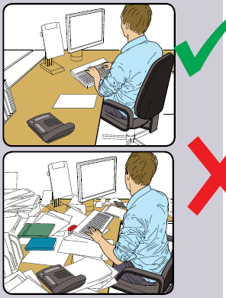 | Create more room by moving printers, reference materials etc. elsewhere.  If necessary, consider providing new power and telecoms sockets, so equipment can be moved.  There should be some scope for flexible rearrangement. | ☐ | ☐
Can the user comfortably reach all the equipment and papers they need to use? | Rearrange equipment, papers etc. to bring frequently used things within easy reach.  A document holder may be needed, positioned to minimise uncomfortable head and eye movements. | ☐ | ☐
Are surfaces free from glare and reflection? | Consider mats or blotters to reduce reflections and glare. | ☐ | ☐
Is the chair suitable? Is the chair stable? Does the chair have a working:  - seat back height and tilt adjustment?  - seat height adjustment?  - castors or glides? | The chair may need repairing or replacing if the user is uncomfortable, or cannot use the adjustment mechanisms. | ☐ | ☐
Is the chair adjusted correctly?  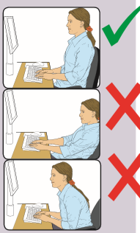 | The user should be able to carry out their work sitting comfortably.  Consider training the user in how to adopt suitable postures while working.  The arms of chairs can stop the user getting close enough to use the equipment comfortably.  Move any obstructions from under the desk. | ☐ | ☐
Is the small of the back supported by the chair’s backrest? | The user should have a straight back, supported by the chair, with relaxed shoulders. | ☐ | ☐
Are forearms horizontal and eyes at roughly the same height as the top of the DSE? | Adjust the chair height to get the user’s arms in the right position, and then adjust the DSE height, if necessary. | ☐ | ☐
Are feet flat on the floor, without too much pressure from the seat on the backs of the legs? | If not, a footrest may be needed. | ☐ | ☐
- Posture
Considerations | Ways of reducing the risk | Yes | No | Action(s) to take
Is the screen roughly an arm’s length away from the user? | Rest the top of the palm on the monitor from a comfortable standing position to gauge the distance. | ☐ | ☐
Are the user’s legs, torso, neck and head in line and vertical, displaying a strong core? | Stand tall, ensuring that all reference points are in a vertical line to ensure minimal strain on joints and muscles. | ☐ | ☐
Is the top of the monitor at, or just below, eye level? | The monitor should be set so that the user is not required to tilt or arch their neck or back while standing. | ☐ | ☐
Is the top of the desk surface (where the keyboard and mouse are positioned) at elbow height or just below? | Ensure the keyboard is directly in front of the user, and pushed back so that the forearms are supported by the front part of the desk while typing. | ☐ | ☐
Are the user’s hips and shoulders relaxed when standing (if using a standing desk)? | Shoulders and hips should be dropped at a natural position while standing. | ☐ | ☐
Is the primary screen in line with the user’s standing position (if using a standing desk)? | Position the monitor so that the user is not twisting or tilting their body to view the screen. | ☐ | ☐
Are the user’s arms kept close to their side when using the mouse or keyboard, and forearms supported by the desk area? | Users should not be required to bend or twist their wrists while using the workstation. | ☐ | ☐
Is the user alternating between a sitting and standing position at regular intervals? | Take regular breaks, and change position at regular intervals (e.g. every 40 minutes).  User should build up the period of time spent standing gradually to avoid fatigue.  Declutter items from desks to prevent objects from falling when alternating between positions. | ☐ | ☐
- Environment
Considerations | Ways of reducing the risk | Yes | No | Action(s) to take
Is there enough room to change position and vary movement? | Space is needed to move, stretch and fidget.  Consider reorganising the office layout and check for obstructions.  Cables should be tidy and not a trip or snag hazard. | ☐ | ☐
Is the lighting suitable, e.g. not too bright or too dim to work comfortably? | Users should be able to control light levels, e.g. by adjusting window blinds or light switches.  Consider shading or repositioning light sources or providing local lighting, e.g. desk lamps (but make sure lights don’t cause glare by reflecting off walls or other surfaces). | ☐ | ☐
Does the air feel comfortable? | DSE and other equipment may dry the air.  Circulate fresh air if possible. Plants may help.  Consider a humidifier if discomfort is severe. | ☐ | ☐
Are levels of heat comfortable? | Can heating be better controlled? More ventilation or air conditioning may be required if there is a lot of electronic equipment in the room. Or, can users be moved away from the heat source? | ☐ | ☐
Are levels of noise comfortable? | Consider moving sources of noise, e.g. printers, away from the user. If not, consider soundproofing. | ☐ | ☐
- Other Workstation Questions
Considerations | Ways of reducing the risk | Yes | No | Action(s) to take
Has the checklist covered all the problems you may have working with their DSE? |  | ☐ | ☐
Have you experienced any discomfort or other symptoms which you attribute to working with your DSE? |  | ☐ | ☐
Do you take regular breaks working away from DSE? |  | ☐ | ☐
- Data Protection
Are you aware of the general principles associated with handling personal data whilst working away from the office? | Further information is available at: https://www.aber.ac.uk/en/information-governance/dp/workingremotely/
Are you aware of the actions to take in the event of a potential data breach? | Further information is available at: https://www.aber.ac.uk/en/information-governance/dp/breach/ | ☐ | ☐

Colleagues are individually responsible for the safe keeping and confidentiality of any work documents being used at home.
Step 3 – Line Manager Review of DSE Assessment
Home workers should provide a completed copy of this form to their Line Manager to review. Copies of all completed forms should be retained by Faculties and Professional Service Departments. Where individuals have completed the form online, a copy will automatically be sent to the relevant Line Manager for review.
The Health, Safety and Environment Team are available to provide Line Managers with guidance on any complex cases or issues encountered with members of staff’s current homeworking arrangements. The Health, Safety and Environment Team can be contacted at hasstaff@aber.ac.uk.
When completing the self-assessment form, users should provide a ‘Yes’ or ‘No’ response to each of the considerations included. When reviewing form:
- ‘Yes’ answers require no further action.
- ‘No’ answers will require investigation and/or remedial action. They should record their decisions in the ‘Action to take’ column. Line Managers should ensure that actions have been taken and have resolved the problem. The ‘Ways of reducing risk’ column provides guidance on the types of changes to workstation areas which can be introduced for compliance with relevant legislation and best practice.
Some of the remedial actions can be easily remedied by the user from home, however some actions, primarily relating to the availability of particular equipment, may require additional support.
Should staff require equipment which is available in their usual workstation, ad-hoc requests for building access can be facilitated through following the Guidance issued to Heads of Department for Dealing with Ad-Hoc Exceptional Requests for Building Access. Members of staff, subject to risk assessment considerations and the authorisation of their Head of Department, can access their offices as an exceptional request to collect any workstation (e.g. chairs) or IT (e.g. computers, screens, keyboards, etc.) equipment required to facilitate effective homeworking.
Where specialist equipment is required, and individuals are unable to arrange to collect equipment themselves from their offices (for example if shielding), arranging delivery from the Estates, Facilities and Residences Team may be possible, depending on the particular circumstances of the individual. Such requests should be submitted to efastaff@aber.ac.uk for consideration.
Where new or additional IT equipment is required, all University IT equipment purchases must be undertaken through Information Services, to ensure compliant procurement and quality processes. Requests from Department to purchase additional IT equipment for staff, can be submitted to is@aber.ac.uk or on 01970 62(2400). Information Services are able to arrange for IT Equipment, such as laptops, to be sent directly to the home addresses of relevant staff, to avoid individuals having to visit the University campus to collect new IT equipment.
Where new or additional workstation equipment, such as chairs, are required, requirements should be Departments should ensure compliance with relevant procurement contracts, where appropriate.
Note: Line Mangers must ensure that an asset register is maintained within the Faculty or Department of all equipment that has been removed from University buildings in order for members of staff to be able to work effectively from home.
Sources of Further Information and/or Support
- Virtual workstation consultation sessions are offered by the Health, Safety and Environment Team via Microsoft Teams: https://www.aber.ac.uk/en/hse/emergency/covid19/#virtual-workstation-consultation. Consultation sessions are available to any members of staff by appointment (subject to the availability of a PC or laptop with internet access, microphone and webcam) at the following times each week:
  - Tuesdays 10:00-11:00
  - Thursdays 14:00-15:00
- Health & Safety tips for setting up your workstation at: https://www.aber.ac.uk/en/media/departmental/healthsafetyenvironment/documentmanagementsystem/websitedocuments/Tips-for-setting-up-your-workstation-at-home.pdf
- DSE considerations during the COVID-19 Pandemic: https://www.aber.ac.uk/en/hse/emergency/covid19/#display-screen-equipment-(dse)
- Home Working and Wellbeing Hub: https://www.aber.ac.uk/en/staff/home-working-hub/
- Remote working arrangements FAQs: https://www.aber.ac.uk/en/important-info/coronavirus/coronavirus-faqs-for-staff/remote-working-arrangements/
- Support for Home Working during the Coronavirus pandemic AberNews Article June 2020 edition: https://www.aber.ac.uk/en/media/departmental/news/abernews/Aber-News---June-2020.pdf
Step 4 – Good Working from Home Practices
In addition to ensuring an effective workstation set-up, colleagues should also ensure that they follow good working from home practices, during this period of alternate working arrangements and necessary homeworking. The type of considerations will include, but will not be limited to:
- Getting up and moving or doing stretching exercises (e.g. walking on the spot during virtual meetings or whilst making a phone call). Appendix 1 provides examples of stretches which can be done from your workstation.
- Break up long spells of DSE work with rest breaks (at least 5-10 minutes every hour) or change the activity.
- Avoiding awkward, static postures by regularly changing position.
- Avoiding eye fatigue by changing focus or blinking from time to time.
- Endeavour to keep the duration of all virtual meetings to the absolutely minimum, and where meetings exceed an hour in duration, ensure a short comfort break for all participants to be able to get up and move.
- Avoid arranging back-to-back virtual meetings wherever possible. Try to leave 15 minutes between sessions.
- Pre-book your lunch break into your calendar to assist with taking regular breaks.
- Minimise use of other DSE equipment which may not be used as part of an individuals’ usual work activities, such as headphones or headsets. Colleagues should ensure that headsets’ volume is kept as low as possible, and the use of headsets is minimised as much as possible, and removed when not in use.

Appendix 1 – Examples of Workstation Stretches

Stretches for Wrist, Hand and Forearm
1 | Make a fist; ensuring thumb is straight, not tucked under fingers (1a). Slide fingertips up palm, tips of fingers moving towards base of fingers, until stretch is felt (1b). Hold for slow count of 10. Repeat 3 – 5 times. | 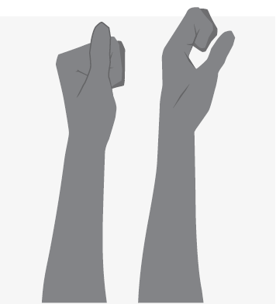
2 | With hand open and facing down, move wrist from side to side, until stretch is felt at each extreme. Hold each for slow count of 10. Repeat 3 – 5 times. | 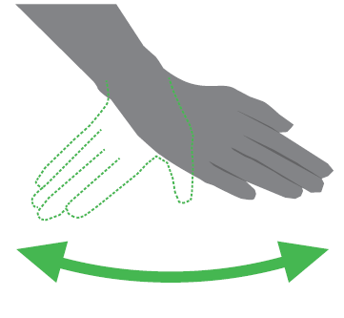
3 | With elbow held close in to side of body, slowly rotate palm upwards and then downwards until stretch is felt at each extreme. Hold each for slow count of 10. Repeat 3 – 5 times. | 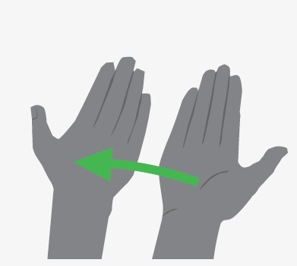
4 | Holding upper part of hand with other hand, slowly bend wrist down and then upwards until stretch is felt at each extreme. Hold each for slow count of 10. Repeat 3 – 5 times. | 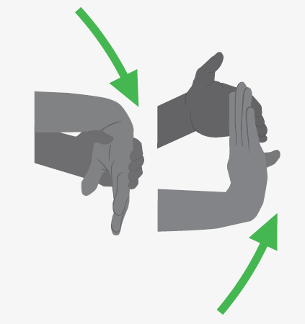
5 | Sitting with elbows out and palms together, slowly rotate palms down until stretch is felt. Hold for slow count of 10. Repeat 3 – 5 times. | 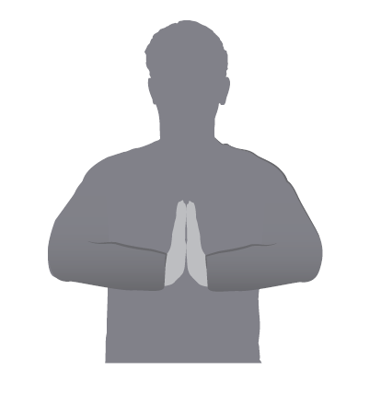

Stretches for Neck and Shoulders
1 | Sit or stand upright. Without lifting chin, glide head straight back until a stretch is felt. Hold for slow count of 10. Repeat 3 – 5 times. | 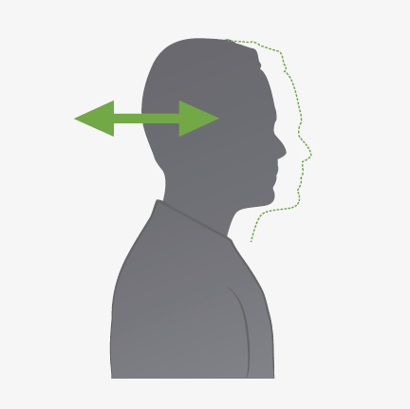
2 | Drop head slowly to one side, taking ear towards shoulder until stretch is felt. Hold for slow count of 10. Repeat 3 – 5 times to each side. | 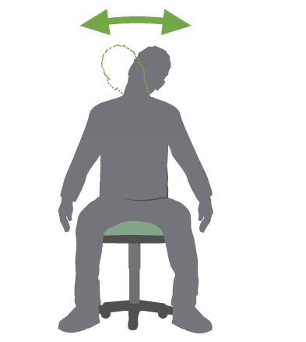
3 | Raise shoulders towards ears until slight tension felt across tops of shoulders. Hold for slow count of 10. Release and repeat 3 – 5 times. | 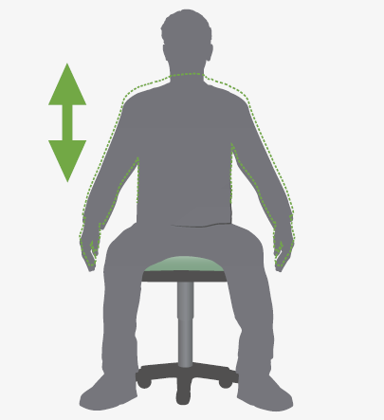
4 | Sitting with back supported, slowly roll shoulders up and backwards in circular motion. Repeat 10 times. | 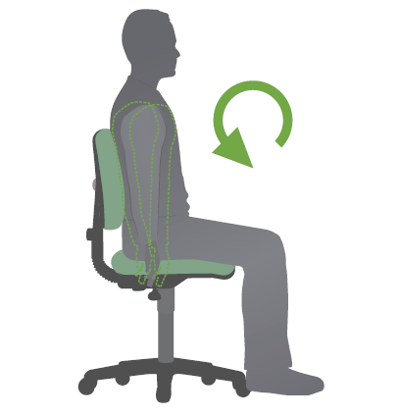

Stretches for Back
1 | Interlace fingers and lift arms above head, keeping elbows straight. Pressing arms back, slowly stretch to one side. Hold for slow count of 10. Repeat 3 – 5 times to each side. | 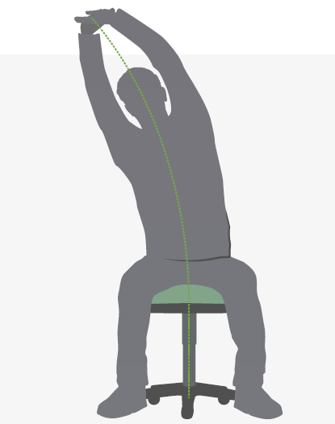
2 | Hold right arm with left hand just above elbow. Gently push elbow towards left shoulder until stretch is felt. Hold for slow count of 10. Repeat 3 – 5 times to each side. | 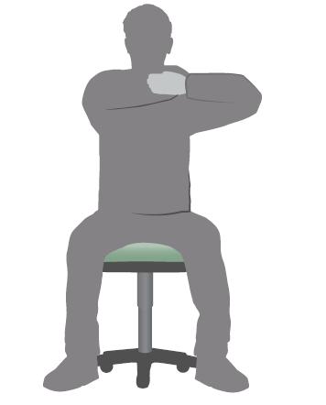
3 | Interlace fingers and lift arms above head. Slowly lean backwards until stretch is felt. Hold for slow count of 10. Repeat 3 – 5 times. | 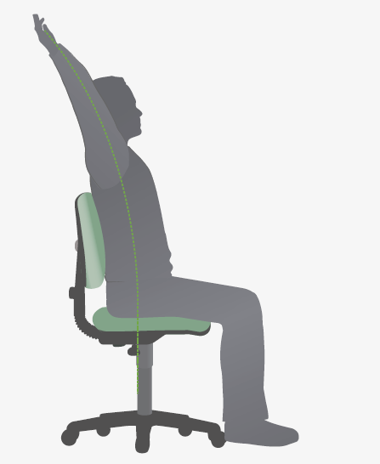

Stretches for Leg and Ankle
1 | Slowly lift one leg, straightening knee. Hold for slow count of 10. Repeat 3 – 5 times with each leg. | 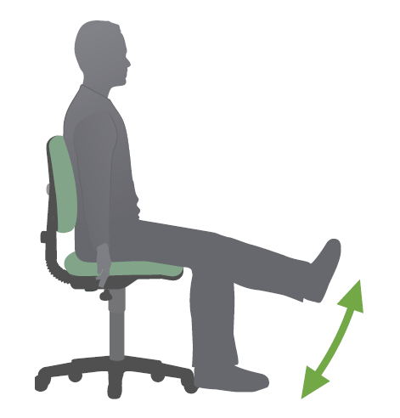
2 | Lift ankle clear of floor. Alternately flex and extend ankle in a pumping action. Repeat 10 times with each ankle. | 